LENDING CLUB DATA ANALYSIS-ML

Applying machine learning models to the data and deploying best model in Azure



**Pranay Mankad**

**Priyesh Kaushik**

1. Classification:

Use the “Loan Data” and the “Declined Loan Data” datasets to build classification models that will generate a flag whether to give a loan or not.

Start with logistic regression using Jupyter and Python/R

• Compute ROC curve and Confusion matrices for training and testing datasets and comment on the results.

• Repeat this using Random Forest, Neural Network models algorithms.

• Choose one model you will deploy and implement this model on the Microsoft azure machine learning studio and create a REST API

• You should be able to a new record (You can define what features you will use) and the result will be a flag whether you would give a loan or not.

FEATURES SELECTED

'Amount_Requested',

'Loan_Title',

'Risk_Score',

'Debt-To-Income_Ratio',

'Employment_Length'

* Logistic Regression:

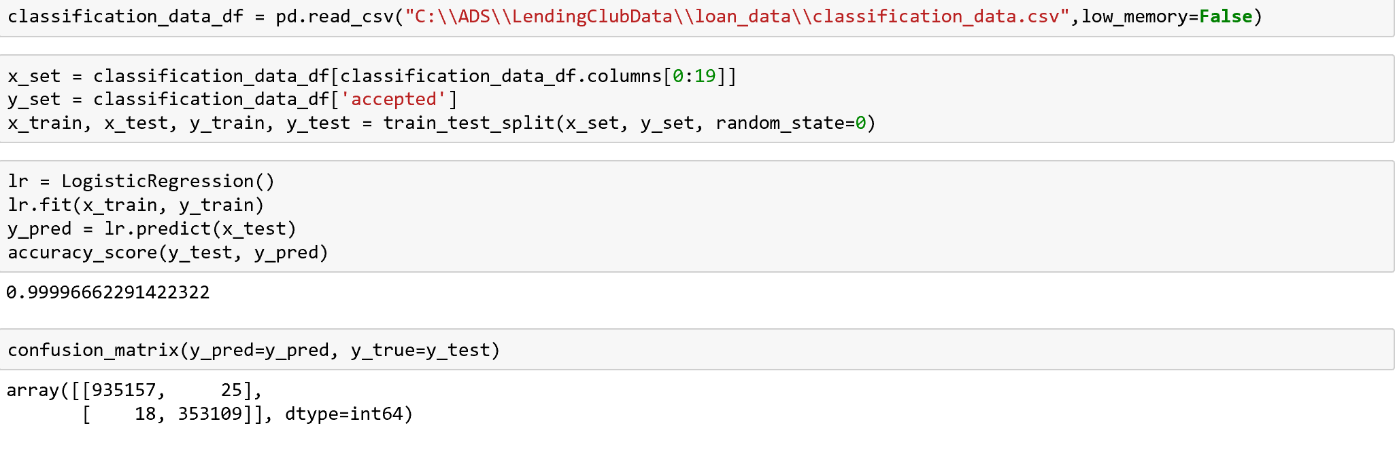

Accuracy : 99.99%

* Random Forrest:

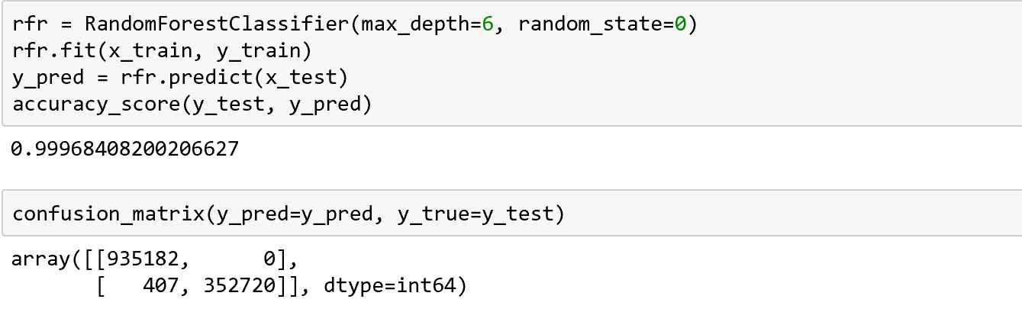

Accuracy : 99.96% (But no false positive 😊 We don’t lose any MONEY $$$$$$)

* Neural Network (Multi-Layer Perceptron)

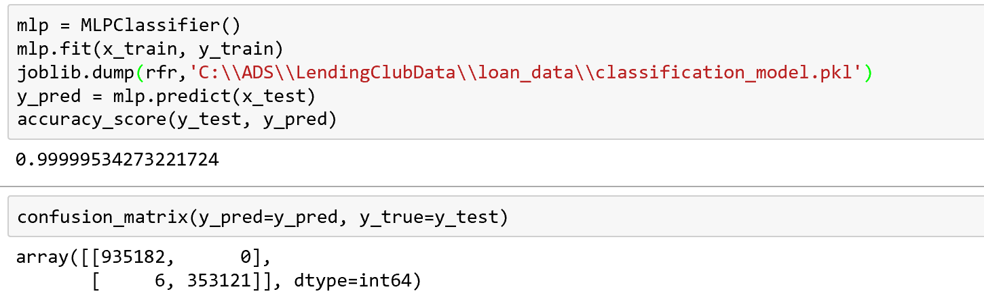

Accuracy: 99.99% (No false positive and only 6 false negative 😊 We don’t lose any MONEY $$$$$$ and possible customers so more $$$$$$)

We deployed the neural net model as it made the most business sense 😊

* Clustering (K-Means)

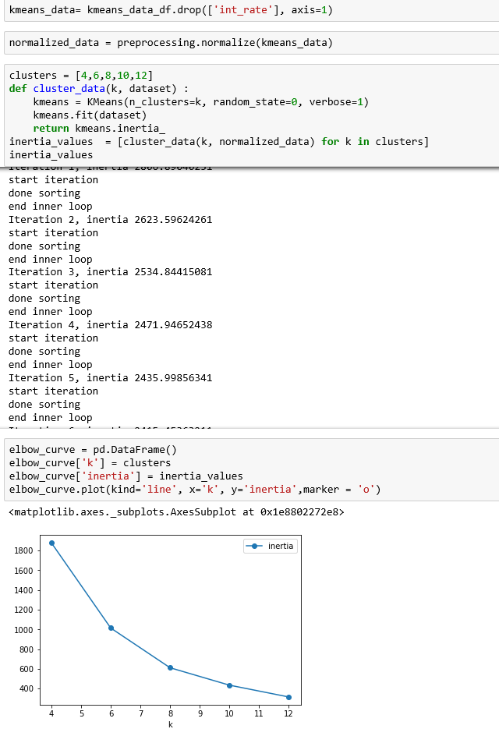

By looking at the Bend curve we can see that the ideal no of cluster would be 8

Hence we create a model with 8 clusters and deploy it

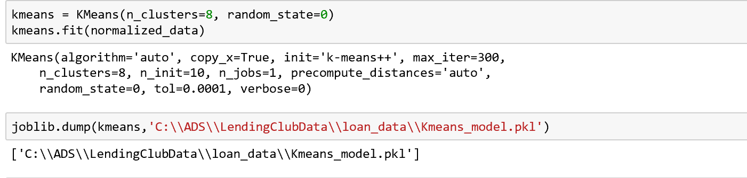

Now we store the data in each cluster into a separate csv to be later used for regression.

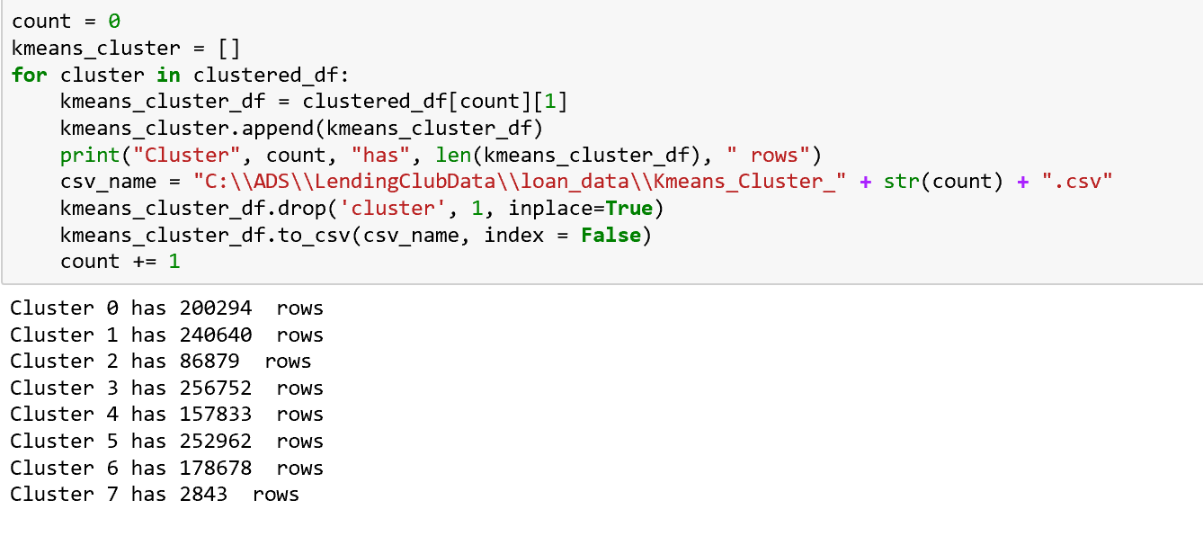

* Clustering (Manual)

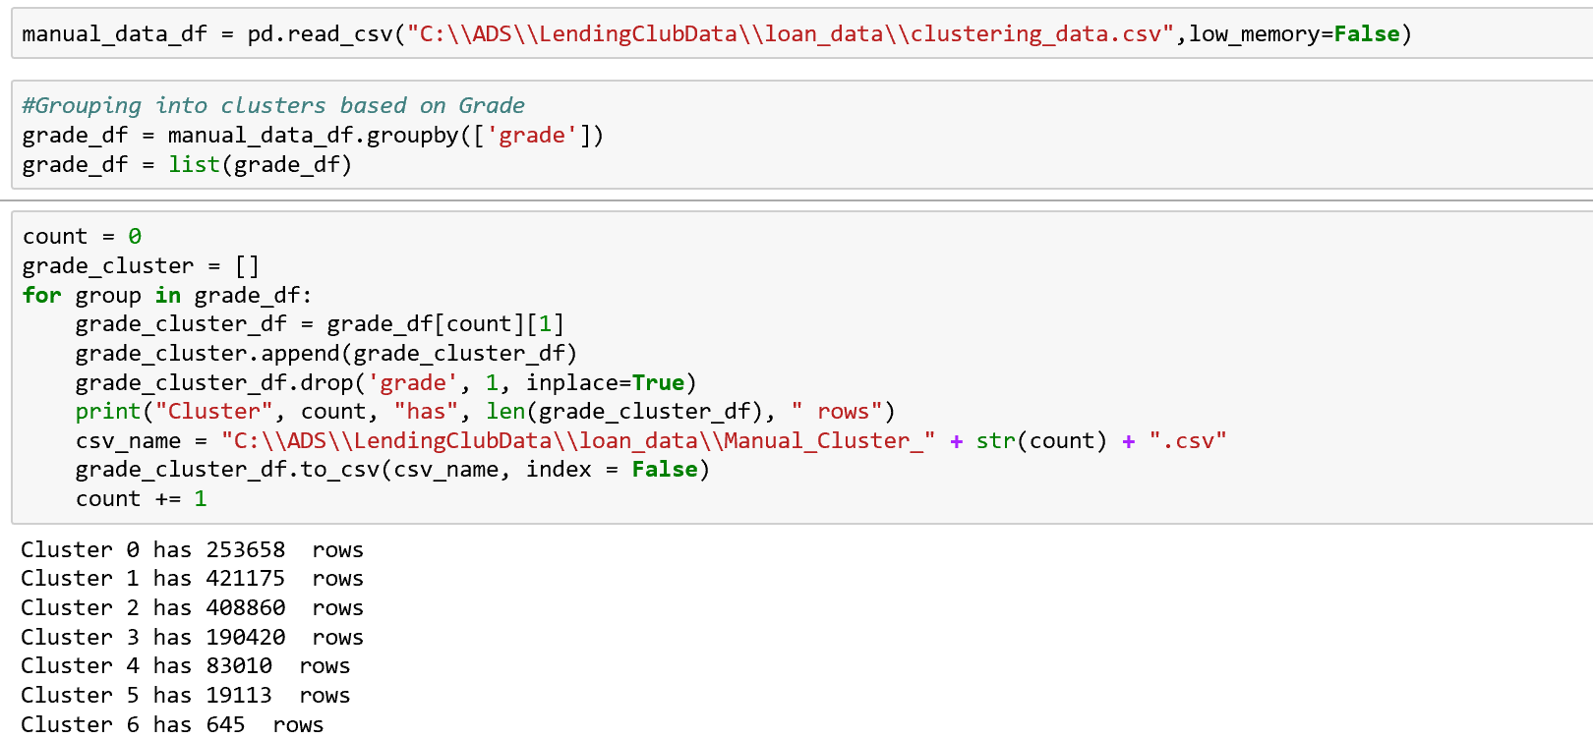

We choose grade as the parameter to cluster the data manually

* TSNE:

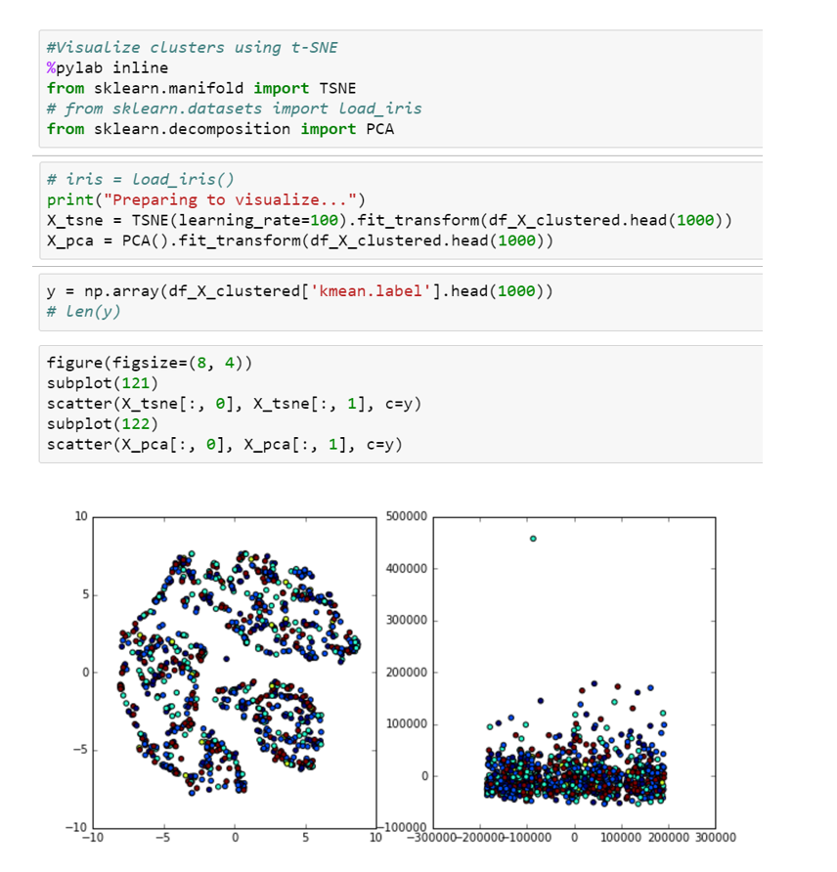

* Prediction:

The RMSE MAE & MAPE for each of the clusters and model are:

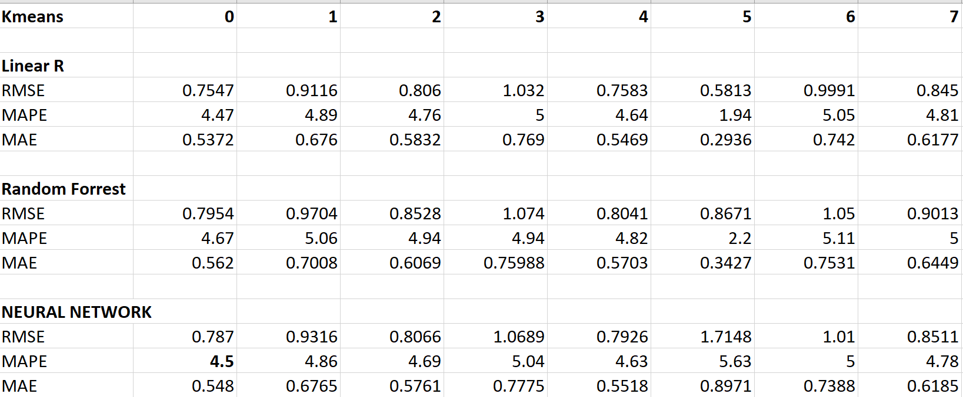

We chose the best model on the basis of these parameters and deployed them on azure.

Sample code for each model:

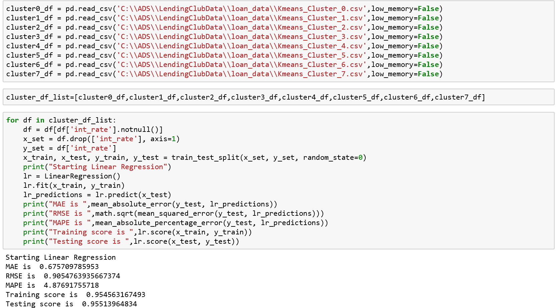

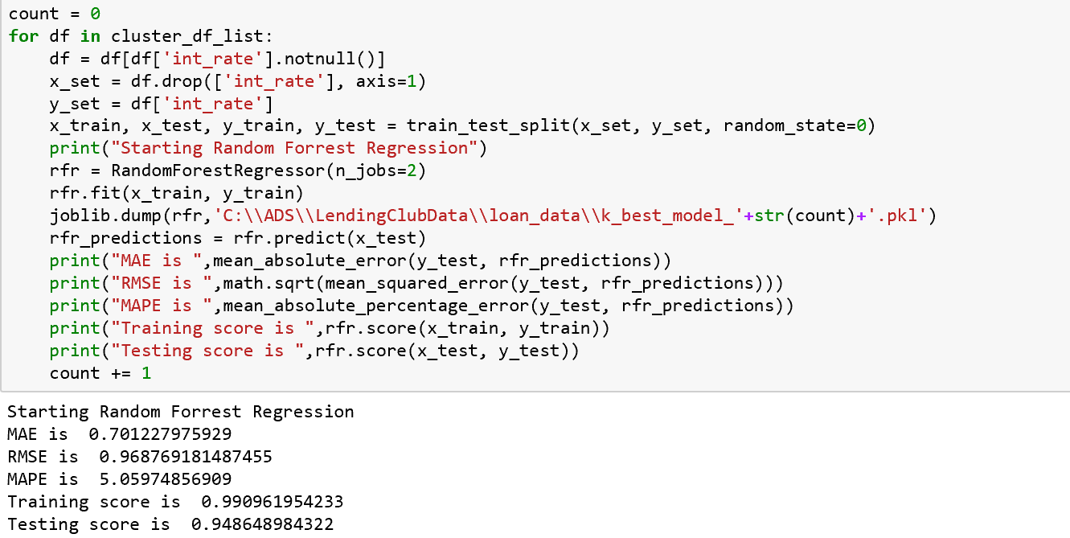

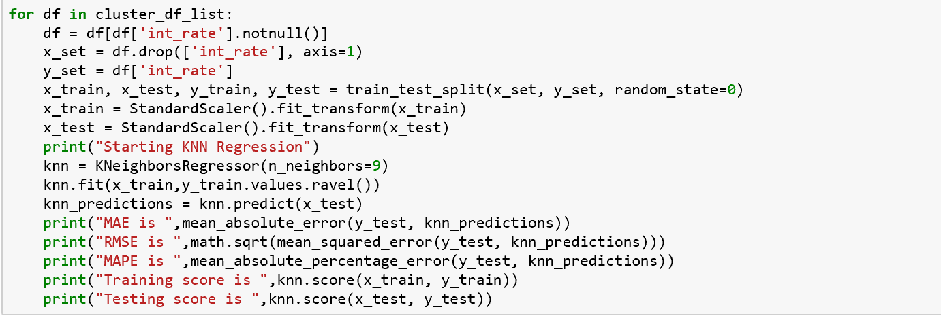

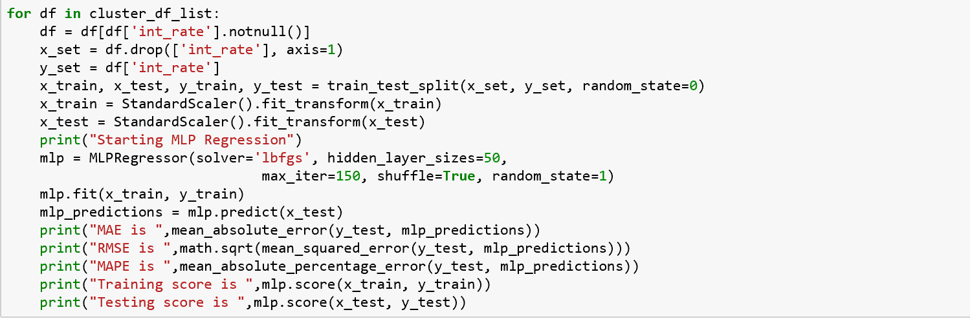

The API call looks like:

